TRƯỜNG ĐẠI HỌC GIAO THÔNG VẬN TẢI THÀNH PHỐ HỒ CHÍ MINH
VIỆN ĐÀO TẠO CHẤT LƯỢNG CAO


MÔN HỌC: CÔNG NGHỆ PHẦN MỀM
BÁO CÁO DỰ ÁN
ĐỀ TÀI: COURSE REGISTRATION SYSTEM
GIẢNG VIÊN HƯỚNG DẪN: Trần Thị Mỹ Tiên
NHÓM: 12
DANH SÁNH NHÓM
HỌ VÀ TÊN | MSSV
Đặng Quốc Khang | 079205006503
Trương Mỹ Phương | 079305012172
Lê Thuỳ Trang | 075306013794
Lê Ngọc Ánh | 051306013023
Đặng Tuấn Phú
MỤC LỤC
1. Functional Requirements 5
FR1: LOGIN 5
FR2: VIEW AVAILABLE COURSES 5
FR3: SEARCH COURSES 5
FR4: REGISTER COURSES 6
FR5: DROP COURSES 6
FR6: VIEW REGISTERED COURSES 6
FR7: VIEW ASSIGNED COURSES 6
FR8: VIEW ENROLLED STUDENTS 7
FR9: MANAGE STUDENTS 7
FR10: MANAGE LECTURERS 7
FR11: MANAGE COURSES 7
FR12: MANAGE REGISTRATION PERIODS 7
2. Non-Functional Requirements 8
3. Data Flow Diagram 10
4. Use case Diagram 12
UC-01 LOGIN 15
UC-02 LOGOUT 17
UC-03 VIEW PROFILE 18
UC-04 CHANGE PASSWORD 19
UC-05 VIEW AVAILABLE COURSES 21
UC-06 SEARCH COURSES 22
UC-07 VIEW COURSE DETAILS 23
UC-08 REGISTER COURSES 25
UC-09 CHECK PREREQUISITE 26
UC-10 CHECK CREDIT LIMIT 28
UC-11 CHECK SCHEDULE CONFLICT 29
UC-12 CHECK AVAILABLE SEATS 30
UC-13 SAVE REGISTRATION 31
UC-14 JOIN WAITING LIST 32
UC-15 DROP COURSES 34
UC-16 VIEW REGISTERED COURSES 35
UC-17 VIEW TIMETABLE 36
UC-18 VIEW ASSIGNED COURSES 38
UC-19 VIEW ENROLLED STUDENTS 39
UC-20 VERIFY LECTURER PERMISSION 41
UC-21 MANAGE STUDENTS 42
UC-22 CREATE / UPDATE STUDENT 44
UC-23 LOCK / UNLOCK STUDENT 45
UC-24 MANAGE LECTURERS 46
UC-25 CREATE / UPDATE LECTURER 48
UC-26 LOCK / UNLOCK LECTURER 49
UC-27 MANAGE COURSES 51
UC-28 SET PREREQUISITES 52
UC-29 CREATE / UPDATE / DELETE COURSE 53
UC-30 MANAGE COURSE SECTIONS 55
UC-31 CREATE COURSE SECTION 56
UC-32 ASSIGN LECTURER 58
UC-33 SET SCHEDULE AND CAPACITY 59
UC-34 MANAGE REGISTRATION PERIODS 60
UC-35 CREATE REGISTRATION PERIOD 61
UC-36 OPEN / CLOSE REGISTRATION 62
UC-37 SET START / END DATES 64
5. Class Diagram 70
6. Data Model 71
7. Interface Design Description 72
7.1 Login Interface 72
7.2 Student Dashboard 73
7.3 Available Courses Interface 74
7.4 Search Courses Interface 75
7.5 Register Course Interface 76
7.6 My Courses Interface 77
7.7 Timetable Interface 78
7.8 Lecturer Dashboard 79
7.9 Assigned Courses Interface 80
7.10 Enrolled Students Interface 81
7.11 Admin Dashboard 82
7.12 Manage Students Interface 83
7.13 Manage Lecturers Interface 84
7.14 Manage Courses Interface 85
7.15 Registration Periods Interface 86

Introducing the Course Registration System
In universities, course registration is an important process that allows students to select courses for each semester. In traditional registration methods, managing course information, class capacities, prerequisites and student enrollments can be time-consuming and may lead to errors.
Students may face difficulties in checking available courses, registration schedules, prerequisite requirements and schedule conflicts. Lecturers need an efficient way to view assigned course sections and enrolled students. Administrators must manage courses, course sections, user accounts and registration periods effectively.
Therefore, a Course Registration System is needed to automate the registration process, improve management efficiency, reduce manual work, provide accurate and updated information for students, lecturers and administrators.

Functional Requirements

FR1: LOGIN
- Students shall be able to log into the system using their student ID and password.
- Lecturers shall be able to log into the system using their lecturer account.
- Administrators shall be able to log into the system using their administrator account.
- The system shall verify user credentials before granting access.

FR2: VIEW AVAILABLE COURSES
- Students shall be able to view all available courses in the current semester.
- The system shall display course information including course code, course name, credits, lecturer, schedule and available seats.

FR3: SEARCH COURSES
- Students shall be able to search for courses by course code or course name.
- The system shall display matching courses.

FR4: REGISTER COURSES
- Students shall be able to register for one or more courses during the official registration period.
- The system shall verify that the student has successfully completed all prerequisite courses by comparing the selected course with the student's academic records before allowing course registration. For example, a student must pass Programming Techniques before registering for Object-Oriented Programming (OOP).
- The system shall verify that the selected course does not conflict with the student's current timetable.
- The system shall verify that the student has not already registered for the selected course in the current semester.
- The system shall verify that the selected course has available seats before confirming the registration.
- The system shall verify that the student's total registered credits, including the selected course, do not exceed the maximum credit limit allowed for the current semester.
- If all validation checks are successful, the system shall create a registration record, confirm the registration, update the student's timetable, and update the student's total registered credits.
- If any validation check fails, the system shall reject the registration request and display an appropriate error message indicating the reason.

FR5: DROP COURSES
- Students shall be able to drop registered courses before the registration deadline.
- The system shall update the number of available seats after a course is dropped.

FR6: VIEW REGISTERED COURSES
- Students shall be able to view all registered courses.
- Students shall be able to view their timetable.

FR7: VIEW ASSIGNED COURSES
- Lecturers shall be able to view the courses assigned to them.
- Lecturers shall be able to view course schedules.

FR8: VIEW ENROLLED STUDENTS
- Lecturers shall be able to view the list of students enrolled in their courses.

FR9: MANAGE STUDENTS
- Administrators shall be able to create student accounts.
- Administrators shall be able to update student information.
- Administrators shall be able to lock or unlock student accounts.

FR10: MANAGE LECTURERS
- Administrators shall be able to create lecturer accounts.
- Administrators shall be able to update lecturer information.
- Administrators shall be able to lock or unlock lecturer accounts.

FR11: MANAGE COURSES
- Administrators shall be able to create, update and delete courses and course sections.
- Administrators shall be able to assign lecturers to course sections.
- Administrators shall be able to set course schedules and capacities.
- The system shall store course information including course code, course name, credits and prerequisite requirements.

FR12: MANAGE REGISTRATION PERIODS
- Administrators shall be able to create registration periods for each semester.
- Administrators shall be able to set registration start and end dates.
- Administrators shall be able to open or close course registration.
- The system shall allow students to register only during the active registration period.
- The system shall prevent registration after the registration deadline.

Non-Functional Requirements
Usability
- The system shall provide a user-friendly and intuitive interface for students, lecturers and administrators.
- Users shall be able to access major functions within a maximum of 3 clicks from the main menu.
- The system shall display clear error and confirmation messages during course registration and account management.
- The system shall support responsive design for access on desktop and mobile devices
Reliability
- The system shall be available at least 99% of the registration period.
- The system shall maintain data consistency during course registration and course dropping operations.
- The system shall automatically save registration transactions to prevent data loss.
- The system shall recover from unexpected failures without losing registered course information.
Supportability
- The system shall use a modular architecture to facilitate maintenance and future enhancements.
- The source code shall be well documented and follow coding standards.
- The system shall allow administrators to update course, lecturer, and student information without modifying the source code.
- The system shall support future integration with other university systems.

Security
- The system shall require authentication before granting access to any user.
- Passwords shall be stored in encrypted form.
- The system shall implement role-based access control for students, lecturers and administrators.
- The system shall prevent unauthorized access to registration and management functions.
- The system shall automatically log out users after a period of inactivity.
Development Requirement
- Programming Language: Python/Java
- Front-end Technologies: Tkinter.
- Database Management System: My SQL or SQL Server.
- Development Environment (IDE): Visual Studio Code.
- Version Control System: Git/Github.

Data Flow Diagram
Level 0:
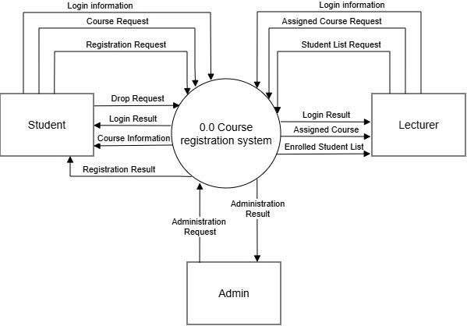
Figure 1: DFD Level 0

Level 1:
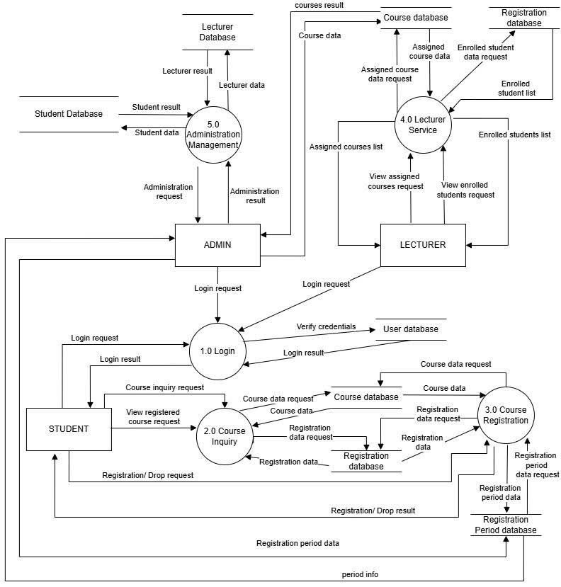
Figure 2: DFD Level 1

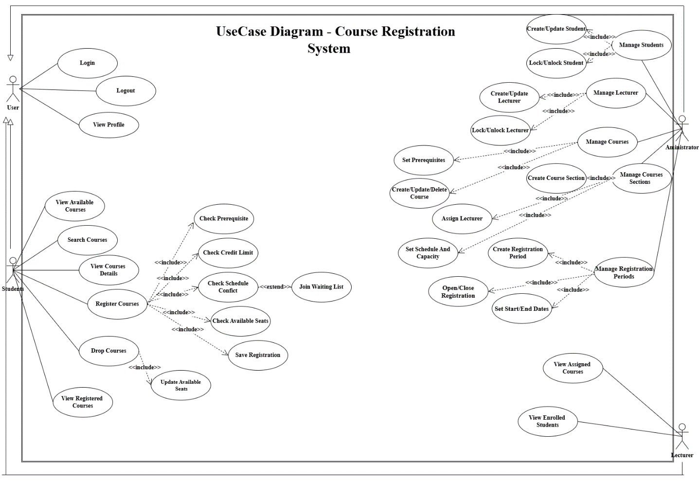
Use case Diagram
Figure 3: Usecase Diagram
Introduction
This report presents a comprehensive use case analysis of the Course Registration System. The report is derived from the project document and the provided use case diagram. The purpose of the system is to automate academic registration activities, improve operational efficiency, and ensure the integrity of academic information throughout the registration lifecycle
Actor Analysis
The system contains four primary actors: User, Student, Lecturer, and Administrator. The User actor represents all authenticated individuals. Students perform course registration activities. Lecturers supervise enrolled students and manage grades. Administrators maintain academic data, user accounts, course structures, and registration periods.

ACTOR
Actor | Description | Responsibilities | Permissions
User | Generic authenticated user | Access account functions | Basic access
Student | Academic participant | Register and drop courses | Student services
Lecturer | Teaching staff member | View assigned courses and enrolled students | Academic supervision
Administrator | System manager | Manage all academic entities | Full administrative access

USE CASE
ID | Use Case | Primary Actor | Description (Specification Summary)
UC-01 | Login | User | Authenticate user credentials to access the system securely.
UC-02 | Logout | User | Terminate the current user session safely.
UC-03 | View Profile | User | Display the personal profile information of the logged-in user.
UC-04 | Change Password | User | Allow users to replace their current password with a new one.
UC-05 | View Available Courses | Student | Browse all available courses offered for the current registration period.
UC-06 | Search Course | Student | Search for courses using keywords or filtering conditions.
UC-07 | View Course Details | Student | Display complete information about a selected course.
UC-08 | Register Course | Student | Register one or more eligible courses for the current semester.
UC-09 | Drop Course | Student | Cancel a previously registered course before the deadline.
UC-10 | View Registered Courses | Student | Display all courses currently registered by the student.
UC-11 | View Timetable | Student | View the personalized class timetable for the semester.
UC-12 | Check Prerequisite | Student | Verify that prerequisite courses have been successfully completed.
UC-13 | Check Credit Limit | Student | Ensure that total registered credits do not exceed university regulations.
UC-14 | Check Schedule Conflict | Student | Detect overlapping class schedules before registration is confirmed.
UC-15 | Check Available Seats | Student | Verify whether seats are still available in the selected course section.
UC-16 | Save Registration | Student | Save the completed course registration into the system database.
UC-17 | Join Waiting List | Student | Join the waiting list when a course section has reached maximum capacity.
UC-18 | Manage Students | Administrator | Manage all student accounts and academic information.
UC-19 | Create/Update Student | Administrator | Create new student records or modify existing student information.
UC-20 | Lock/Unlock Student | Administrator | Enable or disable student accounts when necessary.
UC-21 | Manage Lecturer | Administrator | Supervise lecturer accounts and related information.
UC-22 | Create/Update Lecturer | Administrator | Add new lecturers or update lecturer profiles.
UC-23 | Lock/Unlock Lecturer | Administrator | Activate or deactivate lecturer accounts.
UC-24 | Manage Course | Administrator | Maintain the complete catalog of academic courses.
UC-25 | Create/Update/Delete Course | Administrator | Create, modify, or remove course information from the system.
UC-26 | Set Prerequisite | Administrator | Define prerequisite relationships between academic courses.
UC-27 | Manage Course Sections | Administrator | Manage course sections offered during each semester.
UC-28 | Create Course Section | Administrator | Create new teaching sections for existing courses.
UC-29 | Assign Lecturer | Administrator | Assign lecturers to teach specific course sections.
UC-30 | Set Schedule And Capacity | Administrator | Configure class schedules and maximum student capacity.
UC-31 | Manage Registration Periods | Administrator | Manage registration periods for academic semesters.
UC-32 | Create Registration Period | Administrator | Create a new registration period for course enrollment.
UC-33 | Set Start/End Dates | Administrator | Configure the opening and closing dates of a registration period.
UC-34 | Open/Close Registration | Administrator | Control whether course registration is currently available.
UC-35 | View Assigned Courses | Lecturer | View all course sections assigned for teaching.
UC-36 | View Enrolled Students | Lecturer | Display the list of students enrolled in assigned courses.
UC-37 | Verify Lecturer Permission | Lecturer | Verify that the lecturer has sufficient authorization before performing grading operations.

UC-01 LOGIN
  - Summary
Use Case Name: Login
Use Case ID: UC-01
Use Case Description:
As a system user, I want to authenticate myself using my username and password so that I can securely access the functions and resources available to my role within the Course Registration System.
Actor:
User (Student, Lecturer, Administrator)
Priority:
Critical
Trigger:
The user selects the Login option from the system interface.
Pre-Condition:
The user account must already exist in the system and must not be locked or disabled.
Post-Condition:
The system successfully creates an authenticated session and grants access to the user according to their assigned role.

  - Flow
Main Flow
- The interaction begins when the user navigates to the login page. The system presents an authentication form requesting a username and password. The user enters valid credentials and submits the form.
- The system verifies the supplied credentials against the stored account information. After successful validation, the system determines the user's role and establishes a secure session. The user is then redirected to the appropriate dashboard and can begin using authorized functions.
Alternative Flow
- If the user is already authenticated and attempts to access the login page, the system recognizes the active session and automatically redirects the user to the corresponding dashboard without requesting credentials again.
Exception Flow
- If the username does not exist, the system displays an error message indicating that the account cannot be found.
- If the password is incorrect, the system informs the user that the authentication attempt has failed and allows another login attempt.
- If the account has been locked by an administrator, the system denies access and notifies the user that the account is unavailable.
- If the authentication service becomes unavailable, the login process is terminated and an appropriate system error message is displayed.

UC-02 LOGOUT
  - Summary
Use Case Name: Logout
Use Case ID: UC-02
Use Case Description:
As an authenticated user, I want to terminate my active session so that unauthorized individuals cannot continue using the system on my behalf.
Actor:
User (Student, Lecturer, Administrator)
Priority:
High
Trigger:
The user selects the Logout option.
Pre-Condition:
The user must currently have an active authenticated session.
Post-Condition:
The active session is destroyed and access to protected resources is revoked.
  - Flow
Main Flow
- The user initiates the logout process by selecting the Logout function. The system receives the request and invalidates the active session. All authentication tokens associated with the session are removed.
- Once the session has been successfully terminated, the system redirects the user to the public home page or login page and confirms that logout has been completed.
Alternative Flow
- If multiple browser tabs are open, the logout operation applies to all tabs associated with the same session. Subsequent actions requiring authentication will prompt the user to log in again.

Exception Flow
- If the session has already expired before the logout request is submitted, the system redirects the user to the login page without performing additional logout actions.
- If a system communication error occurs, the session remains inactive once the timeout period expires automatically.

UC-03 VIEW PROFILE
3.1. Summary
Use Case Name: View Profile
Use Case ID: UC-03
Use Case Description:
As a registered user, I want to view my personal account information so that I can verify the accuracy of my profile data stored in the system.
Actor:
User (Student, Lecturer, Administrator)
Priority:
Medium
Trigger:
The user chooses the View Profile function.
Pre-Condition:
The user must be successfully authenticated.
Post-Condition:
The user's profile information is displayed on the screen.
3.2. Flow
Main Flow
- After logging into the system, the user accesses the profile section. The system retrieves all profile information associated with the authenticated account.
- The system presents the profile details including personal information, contact information, and role-specific attributes. The user reviews the information displayed.

Alternative Flow
- Depending on the user's role, the profile page may contain additional information.
- A student may see academic details.
- A lecturer may see teaching-related information.
- An administrator may see administrative privileges and access levels.
Exception Flow
- If profile information cannot be retrieved due to database issues, the system displays a notification indicating that profile data is temporarily unavailable.
- If the session expires while viewing the profile page, the user is redirected to the login screen.

UC-04 CHANGE PASSWORD
  - Summary
Use Case Name: Change Password
Use Case ID: UC-04
Use Case Description:
As an authenticated user, I want to replace my current password with a new one so that I can maintain the security of my account.
Actor:
User (Student, Lecturer, Administrator)
Priority: High
Trigger: The user selects the Change Password function.
Pre-Condition:
The user must be logged into the system and know the current password.
Post-Condition:
The old password becomes invalid and the new password is stored securely.

  - Flow
Main Flow
- The user opens the password management page. The system requests the current password, the new password, and confirmation of the new password.
- The user enters all required information and submits the request. The system validates the current password and verifies that the new password satisfies password policy requirements.
- After successful validation, the system updates the account credentials and confirms that the password change has been completed successfully.
Alternative Flow
- If the new password meets all security requirements but differs only slightly from the previous password, the system may request stronger credentials depending on organizational policy.
Exception Flow
- If the current password is incorrect, the system rejects the request and displays an authentication error.
- If the new password and confirmation password do not match, the update process is cancelled.
- If the new password violates password policy rules, the system informs the user of the specific requirement that has not been satisfied.
- If a database failure occurs during the update process, the original password remains unchanged.

UC-05 VIEW AVAILABLE COURSES
5.1. Summary
Use Case Name: View Available Courses
Use Case ID: UC-05
Use Case Description:
As a student, I want to browse all courses currently available for registration so that I can identify suitable subjects for the upcoming academic period.
Actor: Student
Priority: High
Trigger:
The student accesses the course catalog section.
Pre-Condition:
The student must be authenticated and an active registration period must exist.
Post-Condition:
A list of available courses is displayed to the student.
5.2. Flow
Main Flow
- The student selects the option to view available courses. The system retrieves all courses that are currently open for registration during the active registration period.
- The system organizes the information and presents the available courses, including course code, course title, credit value, instructor information, section information, and remaining seat availability.
- The student reviews the displayed list and may continue with other course-related actions.
Alternative Flow
- The student may choose to sort the displayed courses according to various criteria such as course code, course title, number of credits, or available seats.
- The system reorganizes the displayed data according to the selected sorting preference.
Exception Flow
- If there is no active registration period, the system informs the student that course registration is currently unavailable.
- If no courses are available in the selected semester, the system displays an appropriate notification indicating that no course offerings exist.
- If the database service cannot provide course information, the system displays an error message and terminates the request.

UC-06 SEARCH COURSES
6.1. Summary
Use Case Name: Search Courses
Use Case ID: UC-06
Use Case Description:
As a student, I want to search for specific courses using relevant criteria so that I can quickly locate courses that match my academic needs.
Actor: Student
Priority: Medium
Trigger: The student enters search criteria into the course search interface.
Pre-Condition:
The student must have access to the course catalog.
Post-Condition:
The system displays search results matching the provided criteria.
6.2. Flow
Main Flow
- The student opens the course search feature and enters one or more search conditions such as course code, course name, lecturer name, department, or credit value.
- The system processes the submitted criteria and queries the course database.
- Matching courses are collected and displayed in a structured format. The student reviews the results and may choose to inspect a particular course in greater detail.

Alternative Flow
- The student may combine multiple search filters to narrow the result set.
- The system applies all selected filters and returns only courses satisfying every specified condition.
Exception Flow
- If no course satisfies the search criteria, the system informs the student that no matching results were found.
- If invalid search parameters are supplied, the system requests correction before processing the query.
- If communication with the course database fails, the search operation is aborted and an error notification is displayed.

UC-07 VIEW COURSE DETAILS
7.1. Summary
Use Case Name: View Course Details
Use Case ID: UC-07
Use Case Description:
As a student, I want to inspect detailed information about a selected course so that I can make an informed registration decision.
Actor: Student
Priority: High
Trigger: The student selects a course from the available course list or search results.
Pre-Condition:
The selected course must exist in the system.
Post-Condition:
Detailed course information is displayed to the student.

7.2. Flow
Main Flow
- The student chooses a course from the available course list.
- The system retrieves comprehensive information associated with the selected course. This information includes course code, course title, course description, prerequisite requirements, credit value, assigned lecturer, section schedules, classroom information, and seat availability.
- The system presents the retrieved information in a readable format. The student reviews the details and decides whether the course is suitable for registration.
Alternative Flow
- The student may access course details through either the course catalog or the search result interface.
- Regardless of the entry point, the system retrieves and displays the same detailed information.
Exception Flow
- If the selected course no longer exists, the system notifies the student that the course information is unavailable.
- If the course record becomes inaccessible due to a database error, the system displays an error message and prevents further processing.
- If the course has been cancelled after the course list was generated, the system informs the student that the course is no longer offered.

UC-08 REGISTER COURSES
8.1. Summary
Use Case Name: Register Courses
Use Case ID: UC-08
Use Case Description:
As a student, I want to register for a selected course so that I can enroll in classes required for my academic program during the current semester.
Actor: Student
Priority: Critical
Trigger: The student selects the Register Course function for a course section.
Pre-Condition:
- The student must be authenticated.
- The registration period must be open.
- The selected course section must exist.
Post-Condition:
The student is successfully enrolled in the selected course section or placed on the waiting list when applicable.
8.2. Flow
Main Flow
- The student chooses a course section for registration.
- The system initiates a sequence of mandatory validations including prerequisite verification, credit limit validation, schedule conflict detection, and seat availability checking.
- After all validation procedures complete successfully, the system creates a registration record and associates the selected course section with the student's academic profile.
- The system confirms successful registration and updates the student's registered course list.

Alternative Flow
- If the course section has reached maximum capacity but supports waiting lists, the student may choose to join the waiting list instead of completing direct enrollment.
- The system records the waiting list request and informs the student of their queue position.
Exception Flow
- The registration request is rejected if prerequisite requirements are not satisfied.
- The registration request is rejected if the student's credit limit would be exceeded.
- The registration request is rejected if a timetable conflict exists.
- The registration request is rejected if registration is attempted outside the active registration period.
- The registration request is rejected if the selected course section has been cancelled.

UC-09 CHECK PREREQUISITE
9.1. Summary
Use Case Name: Check Prerequisite
Use Case ID: UC-09
Use Case Description:
As part of course registration, the system verifies whether the student has successfully completed all required prerequisite courses before allowing enrollment.
Actor: System
Priority: Critical
Trigger:
This use case is automatically invoked during course registration.
Pre-Condition:
The selected course must have prerequisite information defined.
Post-Condition:
The system determines whether prerequisite requirements have been satisfied.

9.2. Flow
Main Flow
- The system retrieves the prerequisite requirements associated with the selected course.
- The student's academic history is examined.
- The system compares completed courses against the prerequisite list.
- If all required courses have been completed successfully, prerequisite verification passes and the registration process continues.
Alternative Flow
- If the selected course does not require prerequisites, the system immediately marks prerequisite verification as successful.
Exception Flow
- If one or more prerequisite courses have not been completed, the validation process fails.
- If prerequisite data cannot be retrieved, registration processing is suspended until the issue is resolved.

UC-10 CHECK CREDIT LIMIT
10.1. Summary
Use Case Name: Check Credit Limit
Use Case ID: UC-10
Use Case Description:
As part of the enrollment process, the system evaluates whether the requested registration would exceed the student's maximum permitted credit load.
Actor: System
Priority: Critical
Trigger:
The use case is executed automatically during registration validation.
Pre-Condition:
The student's current semester registration data must exist.
Post-Condition:
The system determines whether the credit limit policy is respected.
10.2. Flow
Main Flow
- The system calculates the total credits already registered by the student.
- The credit value of the selected course is retrieved.
- The system combines the two values and compares the result with the maximum credit limit permitted for the student.
- If the resulting total remains within the permitted threshold, validation succeeds and registration continues.
Alternative Flow
- Students granted special academic permission may possess a higher credit limit.
- The system retrieves the approved limit and applies the adjusted threshold.

Exception Flow
- If the new registration would exceed the permitted credit load, the system rejects the registration request.
- If credit information is unavailable, registration processing is suspended.

UC-11 CHECK SCHEDULE CONFLICT
11.1. Summary
Use Case Name: Check Schedule Conflict
Use Case ID: UC-11
Use Case Description:
As part of course registration, the system verifies that the selected course schedule does not overlap with any course already registered by the student.
Actor: System
Priority: Critical
Trigger:
The validation process is activated during course registration.
Pre-Condition:
The student must already possess timetable information.
Post-Condition:
The system determines whether scheduling conflicts exist.
11.2. Flow
Main Flow
- The system retrieves the meeting schedule of the selected course section.
- The system compares this schedule with all currently registered course schedules belonging to the student.
- If no overlap is detected, validation succeeds and registration processing continues.

Alternative Flow
- If the student has not yet registered for any courses, the system automatically marks the validation as successful.
Exception Flow
- If overlapping timeslots are detected, registration is rejected and conflict information is displayed.
- If timetable data cannot be retrieved, the validation process cannot proceed.

UC-12 CHECK AVAILABLE SEATS
12.1. Summary
Use Case Name: Check Available Seats
Use Case ID: UC-12
Use Case Description:
As part of enrollment validation, the system determines whether sufficient capacity remains in the selected course section.
Actor: System
Priority: Critical
Trigger:
The validation process is executed during course registration.
Pre-Condition:
The course section must have a defined capacity.
Post-Condition:
The system determines whether enrollment space remains available.

12.2. Flow
Main Flow
- The system retrieves the maximum capacity and current enrollment count for the selected course section.
- The system calculates the number of remaining seats.
- If available seats remain, validation succeeds and registration processing continues.
Alternative Flow
- If capacity has been reached but waiting list functionality is enabled, the system offers the waiting list option.
Exception Flow
- If no seats remain and waiting lists are unavailable, registration is denied.
- If enrollment information cannot be retrieved, validation processing fails.

UC-13 SAVE REGISTRATION
13.1. Summary
Use Case Name: Save Registration
Use Case ID: UC-13
Use Case Description:
As part of successful enrollment processing, the system records registration information permanently in the academic database.
Actor: System
Priority: Critical
Trigger:
All registration validations have passed successfully.
Pre-Condition:
Prerequisite, credit, schedule, and seat validations must have succeeded.
Post-Condition:
A permanent registration record is created.
13.2. Flow
Main Flow
- The system generates a registration transaction.
- The selected course section is linked to the student's academic profile.
- Enrollment statistics for the course section are updated.
- The registration transaction is committed to the database and a confirmation message is displayed.
Alternative Flow
- The system may simultaneously generate notification messages confirming enrollment.
Exception Flow
- If the database transaction fails, no registration data is saved.
- If enrollment statistics cannot be updated, the transaction is rolled back.

UC-14 JOIN WAITING LIST
14.1. Summary
Use Case Name: Join Waiting List
Use Case ID: UC-14
Use Case Description:
As a student, I want to join a waiting list when a course section is full so that I may obtain a seat if space becomes available later.
Actor: Student
Priority: Medium
Trigger:
The student chooses the waiting list option after discovering that no seats remain.
Pre-Condition:
The selected course section must support waiting list functionality.
Post-Condition:
The student is placed into the waiting queue.
14.2. Flow
Main Flow
- The student requests to join the waiting list.
- The system verifies eligibility and determines the student's queue position.
- The waiting list entry is created and stored.
- The system confirms successful waiting list enrollment and displays the assigned position.
Alternative Flow
- If a seat becomes available immediately during processing, the system may offer direct enrollment instead of waiting list placement.
Exception Flow
- If waiting list capacity has been reached, the request is rejected.
- If the student already appears on the waiting list, duplicate entries are prohibited.
- If waiting list functionality is disabled, the request cannot proceed.

UC-15 DROP COURSES
15.1. Summary
Use Case Name: Drop Courses
Use Case ID: UC-15
Use Case Description:
This use case enables a student to withdraw from a previously registered course section during the permitted adjustment period. The objective is to allow students to modify their study plan when academic priorities or schedules change.
Actor: Student
Priority: High
Trigger:
The student selects a registered course and requests course withdrawal.
Pre-Condition:
- The student must be logged into the system.
- The student must already be enrolled in the selected course.
- The course drop period must still be active.
Post-Condition:
The selected course is removed from the student's enrollment record and available seats are updated accordingly.
15.2. Flow
Main Flow
- The student opens the list of registered courses.
- The student chooses a course section to drop.
- The system verifies that the withdrawal period remains open.
- The system displays course information and asks for confirmation.
- The student confirms the withdrawal request.
- The system removes the enrollment record and updates seat availability.
- The system displays a successful withdrawal message.

Alternative Flow
- If a waiting list exists for the course section, the system automatically promotes the next eligible student after the seat becomes available.
Exception Flow
- The system rejects the request if the withdrawal deadline has passed.
- The system rejects the request if the selected course is not found in the student's enrollment list.
- The system rejects the request if an unexpected database error occurs during processing.

UC-16 VIEW REGISTERED COURSES
16.1. Summary
Use Case Name: View Registered Courses
Use Case ID: UC-16
Use Case Description:
This functionality provides students with a consolidated view of all course sections currently associated with their academic profile for a particular semester.
Actor: Student
Priority: Medium
Trigger:
The student accesses the Registered Courses page.
Pre-Condition:
The student must be authenticated.
Post-Condition:
The system displays all registered course information.

16.2. Flow
Main Flow
- The student requests to view current registrations.
- The system retrieves enrollment records from the database.
- Course details including section number, lecturer, credits, and schedule are collected.
- The information is presented in a structured format.
- The student reviews the registration information.
Alternative Flow
- The student may filter the displayed information by semester or course category.
- The system refreshes the displayed results according to the selected criteria.
Exception Flow
- If no registrations exist, the system displays an empty enrollment message.
- If enrollment records cannot be retrieved, an error notification is presented.

UC-17 VIEW TIMETABLE
17.1. Summary
Use Case Name: View Timetable
Use Case ID: UC-17
Use Case Description:
This use case allows students to visualize their academic schedule in a calendar-style format, helping them organize study activities and identify potential scheduling concerns.
Actor: Student
Priority: Medium
Trigger:
The student opens the timetable section of the system.
Pre-Condition:
At least one course registration should exist.
Post-Condition:
The student's timetable is displayed.
17.2 Flow
Main Flow
- The student accesses the timetable page.
- The system retrieves all registered course schedules.
- The retrieved schedule data is arranged into a timetable structure.
- The timetable is displayed using days, time slots, and course information.
- The student reviews the schedule.
Alternative Flow
- The student may choose a different semester.
- The system regenerates the timetable using data from the selected semester.
Exception Flow
- If the student has not registered for any courses, the timetable remains empty.
- If schedule information is unavailable, the system displays an error message.

UC-18 VIEW ASSIGNED COURSES
18.1. Summary
Use Case Name: View Assigned Courses
Use Case ID: UC-18
Use Case Description:
This use case enables lecturers to access a complete list of course sections assigned to them for a specific academic semester. It helps lecturers prepare teaching plans and monitor their instructional responsibilities.
Actor: Lecturer
Priority: High
Trigger:
The lecturer opens the Assigned Courses module.
Pre-Condition:
- The lecturer must be authenticated.
- At least one course section has been assigned to the lecturer.
Post-Condition:
The assigned course list is successfully displayed.
18.2. Flow
Main Flow
- The lecturer logs into the Course Registration System and selects the Assigned Courses function.
- The system retrieves all course sections allocated to the lecturer during the selected semester.
- For each assigned course, the system displays the course code, course title, section number, number of enrolled students, classroom, teaching schedule, and semester information.
- The lecturer reviews the course assignments and may proceed to other academic functions.

Alternative Flow
- The lecturer may filter assigned courses by semester or academic year.
- The system refreshes the course list according to the selected academic period.
Exception Flow
- If no teaching assignments exist for the selected semester, the system informs the lecturer that no courses have been assigned.
- If course assignment information cannot be retrieved due to database failure, the system displays an error message and terminates the request.

UC-19 VIEW ENROLLED STUDENTS
19.1 Summary
Use Case Name: View Enrolled Students
Use Case ID: UC-19
Use Case Description:
This functionality allows lecturers to examine the list of students enrolled in one of their assigned course sections. The information supports attendance management, classroom preparation, and academic administration.
Actor: Lecturer
Priority: High
Trigger:
The lecturer selects an assigned course section.
Pre-Condition:
The lecturer must have permission to teach the selected course.
Post-Condition:
The student enrollment list is displayed.

19.2. Flow
Main Flow
- The lecturer chooses one of the assigned course sections.
- The system retrieves the official enrollment records associated with that course.
- The enrolled student list is generated and displayed, including student ID, student name, academic program, registration status, and contact information where permitted.
- The lecturer reviews the information for teaching preparation.
Alternative Flow
- The lecturer may search or filter students using student ID, student name, or registration status.
- The system immediately updates the displayed results based on the selected criteria.
Exception Flow
- If no students have enrolled in the selected course section, the system displays an empty enrollment list.
- If the lecturer attempts to access a course that is not assigned to them, access is denied.
- If enrollment information cannot be retrieved, an appropriate error message is presented.

UC-20 VERIFY LECTURER PERMISSION
20.1. Summary
Use Case Name: Verify Lecturer Permission
Use Case ID: UC-20
Use Case Description:
This use case validates whether a lecturer possesses sufficient authorization to perform academic operations on a selected course. The verification process prevents unauthorized access to teaching resources and student academic records.
Actor:
System
Priority:
Critical
Trigger:
The verification process is automatically initiated before the lecturer accesses protected teaching functions.
Pre-Condition:
- The lecturer must have an active authenticated session.
- The requested course section must exist.
Post-Condition:
The system either grants or denies access based on authorization results.
20.2. Flow
Main Flow
- Before executing a protected academic function, the system identifies the lecturer requesting access.
- The system retrieves the official teaching assignment records.
- The requested course section is compared with the lecturer's assigned responsibilities.
- If authorization is confirmed, permission is granted and the requested operation continues.
Alternative Flow
- If the lecturer possesses additional academic management privileges, the system applies those permissions before making the authorization decision.
Exception Flow
- If the lecturer is not assigned to the requested course, access is denied immediately.
- If authorization records cannot be verified because of system failure, the requested operation is cancelled.

UC-21 MANAGE STUDENTS
21.1. Summary
Use Case Name: Manage Students
Use Case ID: UC-21
Use Case Description:
This use case enables administrators to supervise the complete lifecycle of student accounts within the Course Registration System. It serves as the central function for maintaining accurate student information and ensuring that student records remain valid throughout their academic journey.
Actor: Administrator
Priority: Critical
Trigger:
The administrator opens the Student Management module.
Pre-Condition:
The administrator must be successfully authenticated and possess administrative privileges.
Post-Condition:
Student records are maintained according to the requested management operation.

21.2. Flow
Main Flow
- The administrator navigates to the Student Management module.
- The system retrieves all registered student accounts together with their academic information.
- The administrator reviews the student records and selects an appropriate management operation such as creating, updating, locking, or unlocking a student account.
- The system redirects the administrator to the corresponding management function.
Alternative Flow
- The administrator may search or filter students using student ID, full name, faculty, academic status, or enrollment year.
- The system immediately refreshes the displayed list based on the selected search criteria.
Exception Flow
- If no student records are available, the system displays an empty result page.
- If the student database is temporarily unavailable, the requested management operation cannot continue.

UC-22 CREATE / UPDATE STUDENT
22.1. Summary
Use Case Name: Create / Update Student
Use Case ID: UC-22
Use Case Description:
This use case allows administrators to register new students or modify existing student information so that academic records remain complete, accurate, and up to date throughout each semester.
Actor: Administrator
Priority: Critical
Trigger:
The administrator selects either the Create Student or Update Student function.
Pre-Condition:
The administrator must have permission to modify student information.
Post-Condition:
A new student record is created or an existing student profile is successfully updated.
22.2. Flow
Main Flow
- The administrator selects the desired operation.
- The system presents the student information form.
- The administrator enters or edits personal and academic information, including student ID, full name, email address, faculty, major, and enrollment status.
- The system validates all required fields.
- After successful validation, the system stores the information in the database and confirms completion.
Alternative Flow
- During an update operation, the administrator may modify only selected fields while leaving other information unchanged.
- The system updates only the modified attributes.
Exception Flow
- If the student ID already exists during account creation, the system rejects the request.
- If mandatory information is missing or incorrectly formatted, validation fails.
- If the database transaction cannot be completed, no changes are saved.

UC-23 LOCK / UNLOCK STUDENT
23.1. Summary
Use Case Name: Lock / Unlock Student
Use Case ID: UC-23
Use Case Description:
This use case provides administrators with the ability to temporarily suspend or restore student access to the Course Registration System while preserving all academic records.
Actor: Administrator
Priority: High
Trigger:
The administrator selects the Lock or Unlock command for a student account.
Pre-Condition:
The selected student account must already exist.
Post-Condition:
The student's account status is updated accordingly.
23.2. Flow
Main Flow
- The administrator locates the target student account.
- The current account status is displayed.
- The administrator selects either Lock or Unlock.
- The system requests confirmation before applying the action.
- Once confirmed, the account status is updated and the administrator receives a confirmation message.

Alternative Flow
- The administrator may cancel the operation before confirmation.
- The system closes the confirmation dialog without modifying the account status.
Exception Flow
- If the student account cannot be found, the requested operation is cancelled.
- If the account status has already changed because of another administrator's action, the system refreshes the displayed information.

UC-24 MANAGE LECTURERS
24.1. Summary
Use Case Name: Manage Lecturers
Use Case ID: UC-24
Use Case Description:
This use case enables administrators to oversee lecturer information and teaching assignments by providing centralized management of lecturer accounts within the academic system.
Actor: Administrator
Priority: Critical
Trigger:
The administrator enters the Lecturer Management module.
Pre-Condition:
The administrator must possess full administrative privileges.
Post-Condition:
Lecturer records become available for further administrative operations.

24.2. Flow
Main Flow
- The administrator opens the Lecturer Management interface.
- The system retrieves lecturer records together with department and teaching information.
- The administrator reviews the displayed information and selects an appropriate management function, including creating, updating, locking, or unlocking lecturer accounts.
- The selected management operation is initiated.
Alternative Flow
- The administrator may search lecturers by lecturer ID, faculty, department, academic title, or employment status.
- The displayed information is filtered according to the selected conditions.
Exception Flow
- If no lecturer information exists, the system displays an empty management page.
- If lecturer information cannot be retrieved due to system failure, the operation is interrupted.

UC-25 CREATE / UPDATE LECTURER
25.1. Summary
Use Case Name: Create / Update Lecturer
Use Case ID: UC-25
Use Case Description:
This use case allows an administrator to establish new lecturer accounts or maintain existing lecturer information. The objective is to ensure that teaching personnel records remain accurate and synchronized with institutional data.
Actor: Administrator
Priority: Critical
Trigger:
The administrator chooses to create a new lecturer or edit an existing lecturer profile.
Pre-Condition:
The administrator must have permission to manage lecturer information.
Post-Condition:
The lecturer record is successfully created or updated.
25.2. Flow
Main Flow
- The administrator selects either the create or update operation.
- The system displays the lecturer information form.
- The administrator enters or modifies lecturer details including lecturer ID, full name, email address, faculty, department, academic title, and employment status.
- The system validates the submitted information.
- After successful validation, the lecturer record is stored in the database and the administrator receives a confirmation message.

Alternative Flow
- The administrator may update only selected fields while preserving all remaining lecturer information.
Exception Flow
- If the lecturer ID already exists during account creation, the system rejects the request.
- If mandatory information is incomplete or invalid, validation fails.
- If the database transaction cannot be completed, no changes are saved.

UC-26 LOCK / UNLOCK LECTURER
26.1. Summary
Use Case Name: Lock / Unlock Lecturer
Use Case ID: UC-26
Use Case Description:
This functionality enables administrators to temporarily suspend or restore lecturer accounts without affecting historical teaching assignments or academic records.
Actor: Administrator
Priority: High
Trigger:
The administrator selects the Lock or Unlock option for a lecturer account.
Pre-Condition:
The lecturer account must exist.
Post-Condition:
The lecturer account status is updated successfully.

26.2. Flow
Main Flow
- The administrator locates the lecturer account.
- The system displays the current account status.
- The administrator chooses either Lock or Unlock.
- After confirmation, the system updates the lecturer's account status.
- A success notification is displayed.
Alternative Flow
- The administrator may cancel the operation before confirmation, leaving the account unchanged.
Exception Flow
- If the lecturer account cannot be found, the operation is cancelled.
- If another administrator has already modified the account status, the latest information is refreshed before continuing.

UC-27 MANAGE COURSES
27.1. Summary
Use Case Name: Manage Courses
Use Case ID: UC-27
Use Case Description:
This use case serves as the central management function for maintaining course information throughout the academic system. It enables administrators to supervise the complete course catalog and prepare courses for future registration periods.
Actor: Administrator
Priority: Critical
Trigger:
The administrator opens the Course Management module.
Pre-Condition:
The administrator must be authenticated.
Post-Condition:
Course information becomes available for administrative management.
27.2. Flow
Main Flow
- The administrator enters the Course Management interface.
- The system retrieves the complete course catalog.
- Course information is displayed including course code, title, credits, department, prerequisite status, and current availability.
- The administrator reviews existing courses and selects an appropriate management operation.
Alternative Flow
- The administrator may search or filter courses by department, faculty, course code, credits, or status.
- The displayed course list is updated according to the selected filters.
Exception Flow
- If no courses exist in the system, an empty course catalog is displayed.
- If course information cannot be retrieved, the requested operation is interrupted.

UC-28 SET PREREQUISITES
28.1. Summary
Use Case Name: Set Prerequisites
Use Case ID: UC-28
Use Case Description:
This use case allows administrators to define prerequisite relationships between courses, ensuring that students complete the required academic foundation before enrolling in advanced subjects.
Actor: Administrator
Priority: High
Trigger:
The administrator selects the prerequisite management function.
Pre-Condition:
The target course must already exist.
Post-Condition:
Prerequisite relationships are successfully stored.
28.2. Flow
Main Flow
- The administrator selects a course.
- The system displays the current prerequisite configuration.
- The administrator selects one or more prerequisite courses.
- The system validates the prerequisite structure to prevent invalid relationships.
- The prerequisite configuration is saved successfully.

Alternative Flow
- The administrator may remove existing prerequisite courses.
- The system updates the prerequisite configuration accordingly.
Exception Flow
- If a circular prerequisite dependency is detected, the system rejects the configuration.
- If prerequisite courses do not exist, validation fails.

UC-29 CREATE / UPDATE / DELETE COURSE
29.1. Summary
Use Case Name: Create / Update / Delete Course
Use Case ID: UC-29
Use Case Description:
This use case provides administrators with complete control over the lifecycle of academic courses, allowing new courses to be introduced, existing courses to be revised, or obsolete courses to be removed when appropriate.
Actor: Administrator
Priority: Critical
Trigger:
The administrator selects one of the available course maintenance operations.
Pre-Condition:
The administrator must possess full course management privileges.
Post-Condition:
The selected course maintenance operation is completed successfully.

29.2. Flow
Main Flow
- The administrator selects Create, Update, or Delete.
- The system displays the corresponding operation interface.
- The administrator enters or modifies course information or confirms course deletion.
- The system validates all business rules.
- The requested operation is committed to the database.
- The system confirms successful completion.
Alternative Flow
- Instead of permanent deletion, the administrator may mark a course as inactive.
- Inactive courses remain in historical academic records but cannot be registered.
Exception Flow
- Courses currently used by existing registrations cannot be deleted.
- Duplicate course codes are rejected during creation.
- Database failures prevent the operation from being completed.

UC-30 MANAGE COURSE SECTIONS
30.1. Summary
Use Case Name: Manage Course Sections
Use Case ID: UC-30
Use Case Description:
This use case provides administrators with centralized control over course sections offered in each semester. Through this function, administrators organize how individual classes are delivered while ensuring that every section is properly configured before student registration begins.
Actor: Administrator
Priority: Critical
Trigger:
The administrator opens the Course Section Management module.
Pre-Condition:
The administrator has successfully logged into the system.
Courses have already been created.
Post-Condition:
Course sections are available for creation, modification, lecturer assignment, scheduling, and capacity configuration.
30.2. Flow
Main Flow
- The administrator accesses the Course Section Management page.
- The system retrieves all existing course sections for the selected semester.
- The administrator reviews section information including course code, section number, assigned lecturer, schedule, classroom, enrollment status, and capacity.
- The administrator chooses an operation related to course section management.

Alternative Flow
- The administrator filters sections by semester, department, course, or lecturer.
- The displayed information is updated according to the selected criteria.
Exception Flow
- If no sections exist for the selected semester, the system displays an empty list.
- If section information cannot be retrieved, the requested operation is cancelled.

UC-31 CREATE COURSE SECTION
31.1. Summary
Use Case Name: Create Course Section
Use Case ID: UC-31
Use Case Description:
This functionality enables administrators to establish new teaching sections for existing courses so that students can register for multiple class offerings during an academic semester.
Actor: Administrator
Priority: Critical
Trigger:
The administrator selects the Create Course Section function.
Pre-Condition:
- The corresponding course already exists.
- The semester has been configured.
Post-Condition:
A new course section is successfully created.

31.2. Flow
Main Flow
- The administrator selects an existing course.
- The system displays the course section creation form.
- The administrator enters the section number and other required information.
- The system validates that the section number is unique within the selected course.
- The course section is created and stored successfully.
Alternative Flow
- The administrator may create multiple sections for the same course during a single management session.
Exception Flow
- If the section number already exists, the system rejects the creation request.
- If required information is incomplete, validation fails.
- If database storage fails, the section is not created.

UC-32 ASSIGN LECTURER
32.1. Summary
Use Case Name: Assign Lecturer
Use Case ID: UC-32
Use Case Description:
This use case allows administrators to allocate teaching responsibilities by assigning qualified lecturers to specific course sections before the semester begins.
Actor: Administrator
Priority: High
Trigger:
The administrator selects the Assign Lecturer function.
Pre-Condition:
- The course section exists.
- The lecturer account exists.
Post-Condition:
The selected lecturer is assigned to the course section.
32.2. Flow
Main Flow
- The administrator selects a course section.
- The system displays a list of eligible lecturers.
- The administrator chooses an appropriate lecturer.
- The system verifies lecturer availability.
- The assignment is saved successfully.
Alternative Flow
- The administrator may replace the currently assigned lecturer before the semester begins.
Exception Flow
- If the lecturer has a scheduling conflict, assignment is rejected.
- If the lecturer account is inactive, assignment cannot proceed.

UC-33 SET SCHEDULE AND CAPACITY
33.1. Summary
Use Case Name: Set Schedule and Capacity
Use Case ID: UC-33
Use Case Description:
This functionality enables administrators to define when a course section is conducted and how many students may enroll, ensuring efficient utilization of classrooms and teaching resources.
Actor: Administrator
Priority:
Critical
Trigger:
The administrator edits schedule information for a course section.
Pre-Condition:
The course section has already been created.
Post-Condition:
Schedule and enrollment capacity are successfully updated.
33.2. Flow
Main Flow
- The administrator selects a course section.
- The system displays current scheduling information.
- The administrator specifies meeting days, time slots, classroom, and maximum capacity.
- The system validates scheduling conflicts.
- The updated information is stored successfully.
Alternative Flow
- The administrator adjusts only enrollment capacity while leaving the timetable unchanged.
Exception Flow
- If classroom conflicts exist, the schedule update is rejected.
- If capacity is smaller than current enrollment, the update cannot proceed.

UC-34 MANAGE REGISTRATION PERIODS
34.1. Summary
Use Case Name: Manage Registration Periods
Use Case ID: UC-34
Use Case Description:
This use case enables administrators to supervise registration windows that determine when students are permitted to enroll in courses for each academic semester.
Actor: Administrator
Priority: Critical
Trigger:
The administrator enters the Registration Period Management module.
Pre-Condition:
The administrator is authenticated.
Post-Condition:
Registration period information is available for management.
34.2. Flow
Main Flow
- The administrator opens registration period management.
- The system retrieves all configured registration periods.
- The administrator reviews existing periods and selects an appropriate management function.
Alternative Flow
- Registration periods may be filtered by semester or academic year.
Exception Flow
- If no registration periods exist, an empty management page is displayed.
- If data retrieval fails, management operations cannot continue.

UC-35 CREATE REGISTRATION PERIOD
35.1. Summary
Use Case Name: Create Registration Period
Use Case ID: UC-35
Use Case Description:
This use case allows administrators to establish a new registration window that controls the timeframe during which course enrollment activities are permitted.
Actor: Administrator
Priority: High
Trigger:
The administrator selects Create Registration Period.
Pre-Condition:
The target semester exists.
Post-Condition:
A new registration period is created.
35.2. Flow
Main Flow
- The administrator enters semester information.
- The administrator specifies registration start and end dates.
- The system validates the provided schedule.
- The registration period is stored successfully.

Alternative Flow
- The administrator duplicates a previous registration period and modifies only the dates.
Exception Flow
- If the selected period overlaps another active period, creation fails.
- If required information is incomplete, validation fails.

UC-36 OPEN / CLOSE REGISTRATION
36.1. Summary
Use Case Name: Open / Close Registration
Use Case ID: UC-36
Use Case Description:
This use case enables administrators to activate or deactivate course registration according to the official academic schedule, ensuring that enrollment occurs only within authorized periods.
Actor: Administrator
Priority: Critical
Trigger:
The administrator changes the registration status.
Pre-Condition:
A registration period already exists.
Post-Condition:
Registration status becomes either Open or Closed.

36.2. Flow
Main Flow
- The administrator selects a registration period.
- The current registration status is displayed.
- The administrator chooses either Open or Close.
- The system updates the registration status.
- Students immediately receive the updated registration availability.
Alternative Flow
- The administrator schedules automatic opening and closing according to predefined dates.
Exception Flow
- If registration is already in the selected state, no update is performed.
- If status updates fail, the previous registration state is preserved.

UC-37 SET START / END DATES
37.1. Summary
Use Case Name: Set Start / End Dates
Use Case ID: UC-37
Use Case Description:
This use case enables administrators to configure the official opening and closing dates for a registration period, ensuring that enrollment activities follow the academic calendar established by the institution.
Actor: Administrator
Priority: High
Trigger:
The administrator edits registration period dates.
Pre-Condition:
A registration period already exists.
Post-Condition:
The new registration dates are successfully stored.
37.2. Flow
Main Flow
- The administrator selects an existing registration period.
- The current start and end dates are displayed.
- The administrator specifies the revised dates.
- The system validates chronological consistency.
- The updated dates are saved successfully.
Alternative Flow
- The administrator modifies only the end date while preserving the original start date.
Exception Flow
- If the end date occurs before the start date, validation fails.
- If the registration period has already ended, date modification may be prohibited according to institutional policy.
- If database updates fail, the original schedule remains unchanged.

Include Relationship Analysis
The use case diagram employs include relationships to model mandatory sub-processes that must be executed as part of a larger business process. The Register Course use case includes Check Prerequisite, Check Credit Limit, Check Schedule Conflict, and Check Available Seats. These validations ensure academic compliance before registration can be finalized. Administrative management functions also include lower-level operational use cases such as Create/Update Student, Lock/Unlock Student, Create Course Section, Assign Lecturer, and Set Schedule and Capacity. The use of include relationships reduces redundancy and improves maintainability because common validation logic is centralized and reused across the system.
Extend Relationship Analysis
The extend relationship is used when behavior is conditional rather than mandatory. Join Waiting List extends Register Course when no seats are available. Print Timetable extends View Timetable because printing is optional and only occurs upon user request. This modeling technique improves flexibility and keeps the primary use case focused on its core objective while allowing optional functionality to be added under specific circumstances.

Functional Requirement to Use Case Traceability Matrix
FR | Requirement | Related Use Cases
FR1 | Login | Login
FR2 | View Available Courses | View Available Courses
FR3 | Search Courses | Search Course
FR4 | Register Courses | Register Course, Check Prerequisite, Check Schedule Conflict
FR5 | Drop Courses | Drop Course
FR6 | View Registered Courses | View Registered Courses, View Timetable
FR7 | View Assigned Courses | View Assigned Courses
FR8 | View Enrolled Students | View Enrolled Students
FR9 | Manage Students | Manage Students
FR10 | Manage Lecturers | Manage Lecturer
FR11 | Manage Courses | Manage Course, Manage Course Sections
FR12 | Manage Registration Periods | Manage Registration Periods

Design Justification
The architecture of the Course Registration System follows separation-of-concerns principles. Student functionality is isolated from administrative functions, while lecturer responsibilities are limited to teaching-related activities. This design enhances security, maintainability, scalability, and long-term system evolution. The use case model provides clear traceability from business requirements to software functions and therefore serves as a valuable foundation for detailed design, implementation, and testing.
The architecture of the Course Registration System follows separation-of-concerns principles. Student functionality is isolated from administrative functions, while lecturer responsibilities are limited to teaching-related activities. This design enhances security, maintainability, scalability, and long-term system evolution. The use case model provides clear traceability from business requirements to software functions and therefore serves as a valuable foundation for detailed design, implementation, and testing.
The architecture of the Course Registration System follows separation-of-concerns principles. Student functionality is isolated from administrative functions, while lecturer responsibilities are limited to teaching-related activities. This design enhances security, maintainability, scalability, and long-term system evolution. The use case model provides clear traceability from business requirements to software functions and therefore serves as a valuable foundation for detailed design, implementation, and testing.
The architecture of the Course Registration System follows separation-of-concerns principles. Student functionality is isolated from administrative functions, while lecturer responsibilities are limited to teaching-related activities. This design enhances security, maintainability, scalability, and long-term system evolution. The use case model provides clear traceability from business requirements to software functions and therefore serves as a valuable foundation for detailed design, implementation, and testing.
The architecture of the Course Registration System follows separation-of-concerns principles. Student functionality is isolated from administrative functions, while lecturer responsibilities are limited to teaching-related activities. This design enhances security, maintainability, scalability, and long-term system evolution. The use case model provides clear traceability from business requirements to software functions and therefore serves as a valuable foundation for detailed design, implementation, and testing.
The architecture of the Course Registration System follows separation-of-concerns principles. Student functionality is isolated from administrative functions, while lecturer responsibilities are limited to teaching-related activities. This design enhances security, maintainability, scalability, and long-term system evolution. The use case model provides clear traceability from business requirements to software functions and therefore serves as a valuable foundation for detailed design, implementation, and testing.
The architecture of the Course Registration System follows separation-of-concerns principles. Student functionality is isolated from administrative functions, while lecturer responsibilities are limited to teaching-related activities. This design enhances security, maintainability, scalability, and long-term system evolution. The use case model provides clear traceability from business requirements to software functions and therefore serves as a valuable foundation for detailed design, implementation, and testing.
The architecture of the Course Registration System follows separation-of-concerns principles. Student functionality is isolated from administrative functions, while lecturer responsibilities are limited to teaching-related activities. This design enhances security, maintainability, scalability, and long-term system evolution. The use case model provides clear traceability from business requirements to software functions and therefore serves as a valuable foundation for detailed design, implementation, and testing.

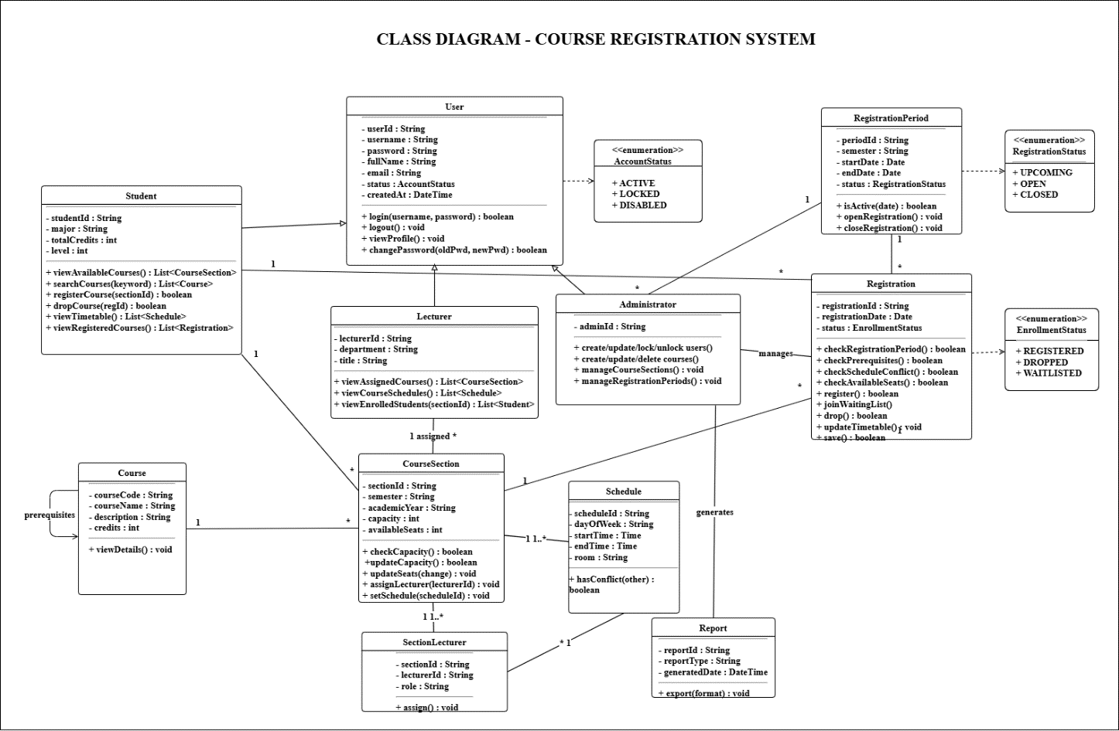
Class Diagram
Figure 4: Class Diagram

Data Model
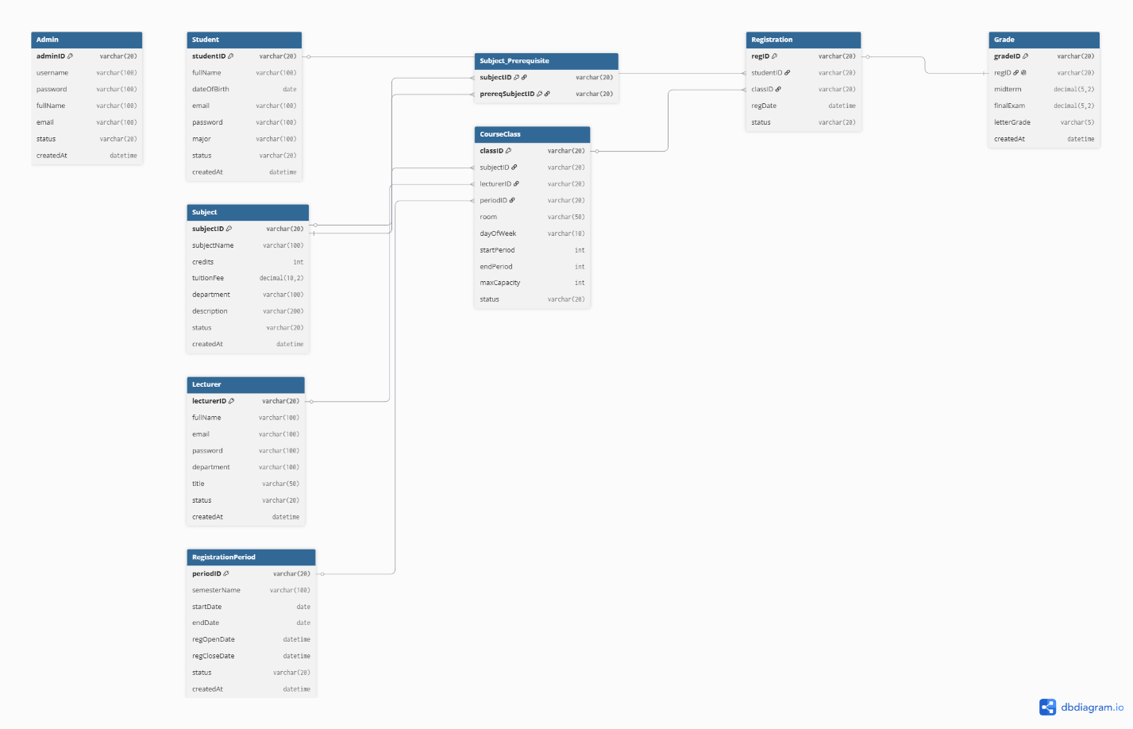
Figure 5: Entity-Relationship Diagram

Interface Design Description

Login Interface
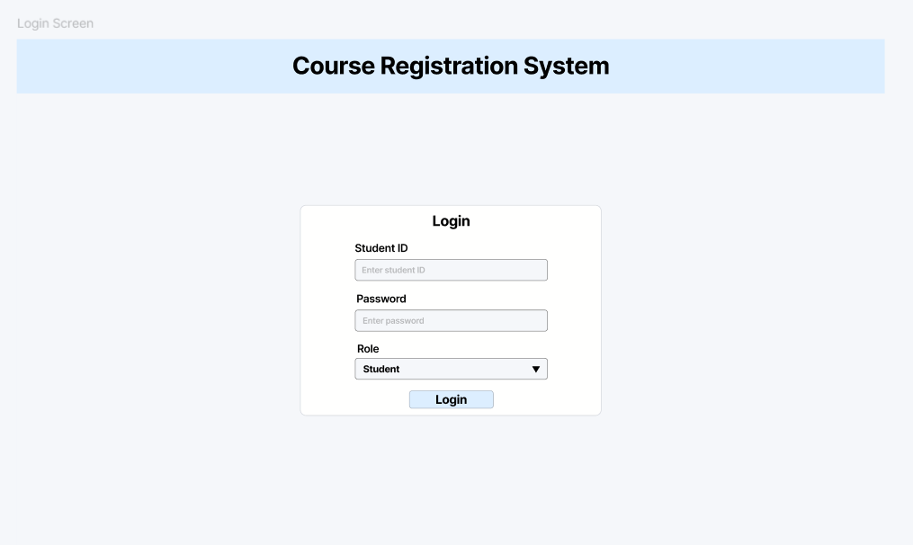
Figure 6: Login Interface

Purpose:
The Login Interface allows students, lecturers, and administrators to access the Course Registration System using their account credentials.
Components
Component | Description
Student ID | Enter user identification number
Password | Enter account password
Role | Select Student, Lecturer, or Administrator
Login Button | Submit login request

Student Dashboard
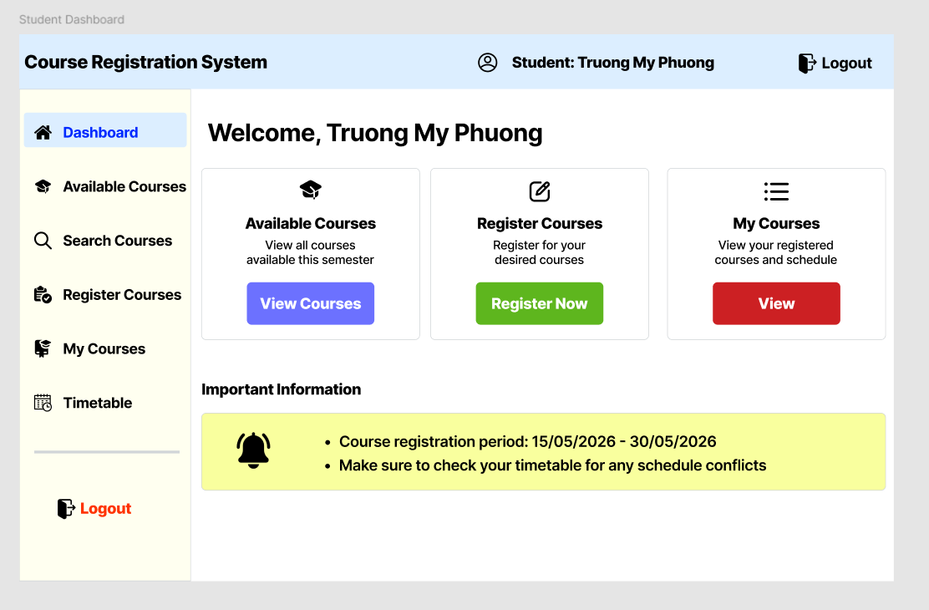
Figure 7: Student Dashboard
Purpose
The Student Dashboard provides quick access to course registration functions and displays important academic information.
Components
Component | Description
Header | Displays system name and user information
Sidebar Menu | Navigation menu for students
Quick Access Cards | Shortcuts to major functions
Welcome Section | Displays student information
Logout Button | Exit the system

Available Courses Interface
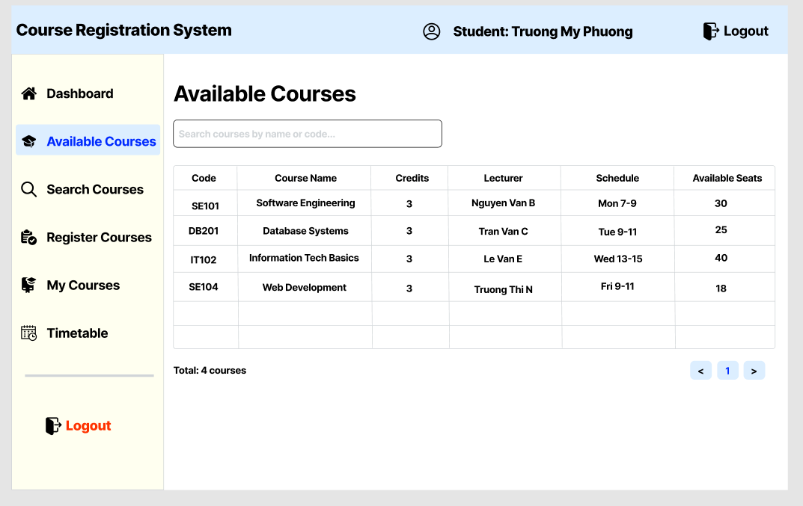
Figure 8: Available Courses Interface
Purpose
This interface allows students to view all courses available for registration in the current semester.
Components
Component | Description
Search Box | Search courses
Course Table | Displays course information
Course Code | Course identifier
Course Name | Course title
Credits | Number of credits
Lecturer | Assigned lecturer
Schedule | Class schedule
Available Seats | Remaining capacity

Search Courses Interface
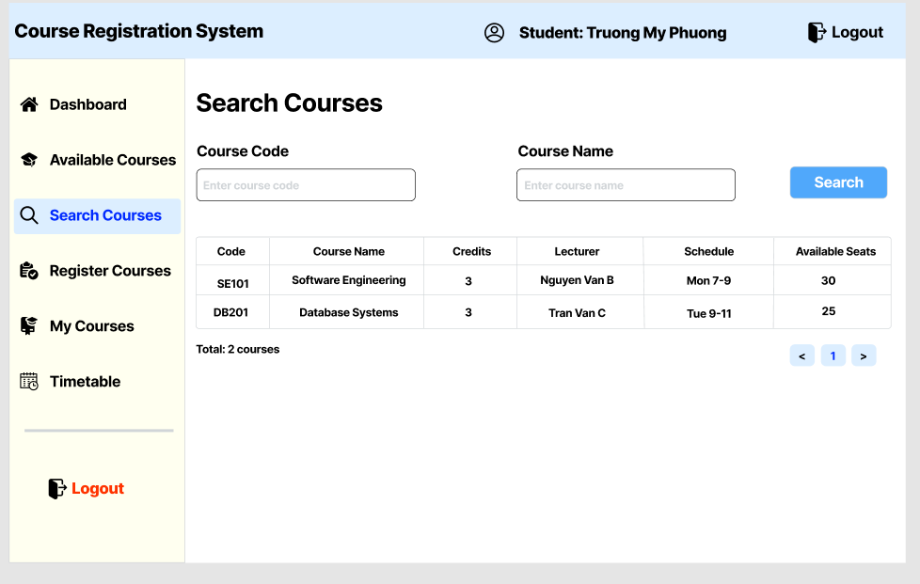
Figure 9: Search Courses Interface
Purpose
This interface allows students to search courses by course code or course name.
Components
Component | Description
Search Input | Enter course code or name
Search Button | Execute search
Result Table | Displays matching courses

Register Course Interface
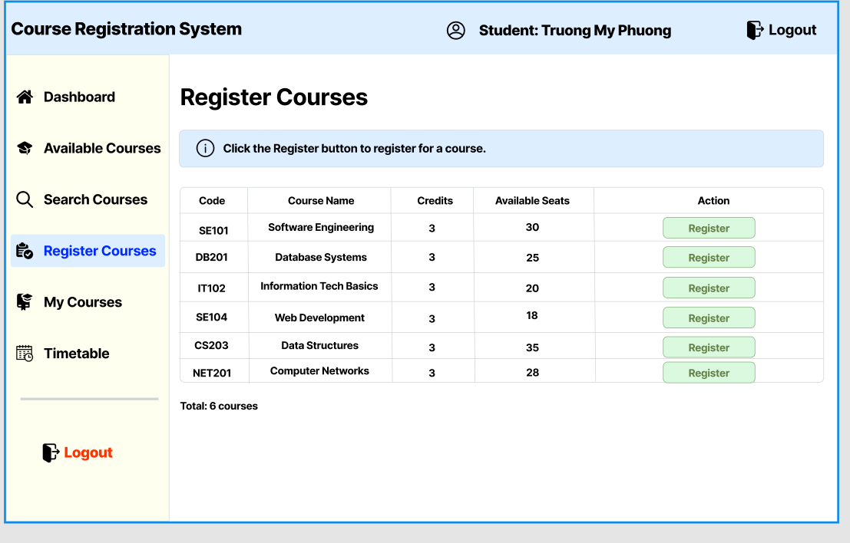
Figure 10: Register Course Interface
Purpose
This interface allows students to register for available courses during the registration period.
Components
Component | Description
Course Table | List of available courses
Register Button | Register selected course
Course Information | Displays course details

My Courses Interface
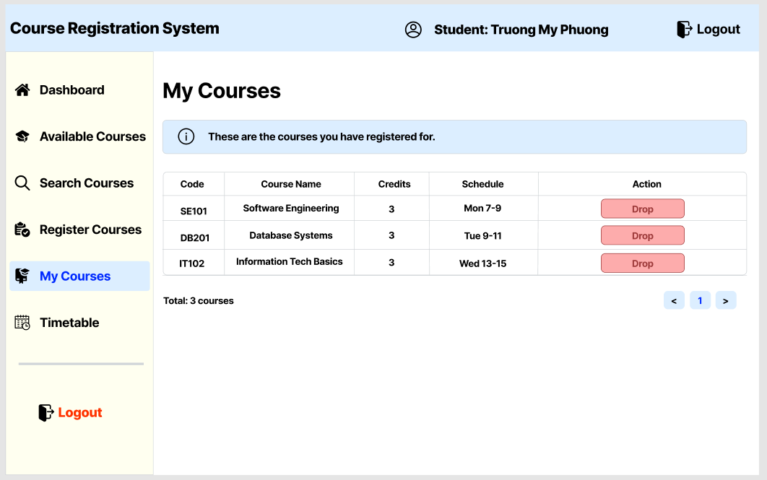
Figure 11: My Courses Interface
Purpose
This interface allows students to view and manage their registered courses.
Components
Component | Description
Registered Course Table | Displays registered courses
Drop Button | Remove selected course
Course Information | Displays registration details

Timetable Interface
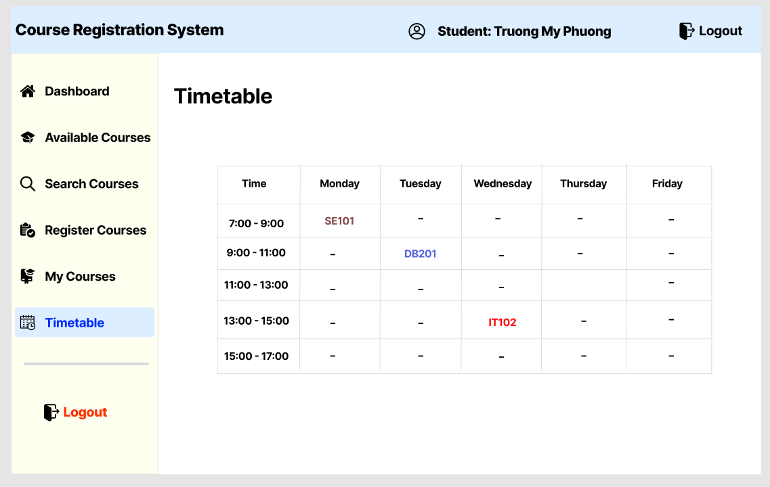
Figure 12: Timetable Interface
Purpose
This interface displays the student's weekly schedule in a timetable format.
Components
Component | Description
Timetable Grid | Weekly class schedule
Time Slots | Class periods
Day Columns | Monday to Saturday
Course Blocks | Registered course sessions

Lecturer Dashboard
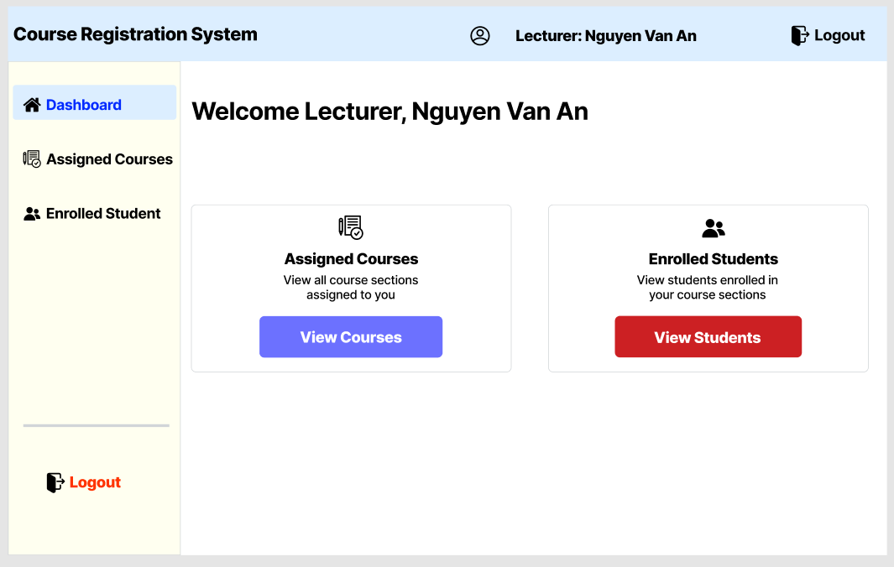
Figure 13: Lecturer Dashboard
Purpose
The Lecturer Dashboard provides quick access to teaching-related information and functions.
Components
Component | Description
Header | Lecturer information
Sidebar Menu | Navigation menu
Assigned Courses Card | View assigned courses
Enrolled Students Card | View enrolled students

Assigned Courses Interface
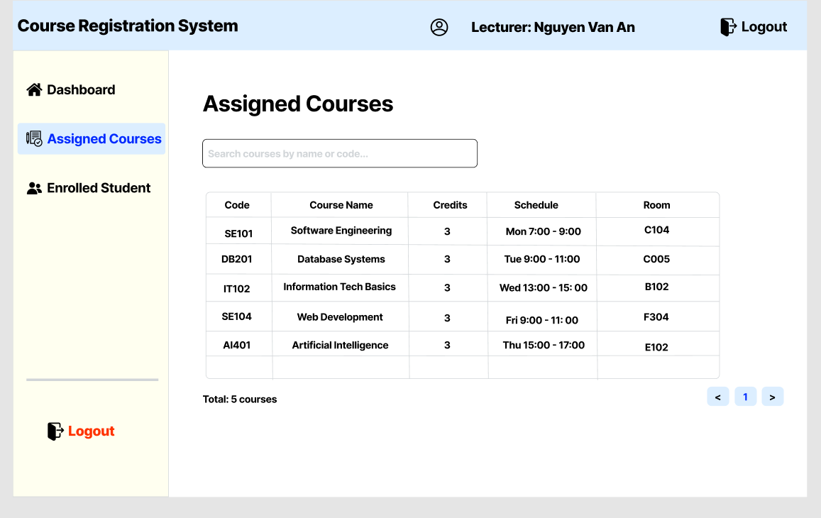
Figure 14: Assigned Courses Interface

Purpose
This interface allows lecturers to view all courses assigned to them.
Components
Component | Description
Search Box | Search assigned courses
Course Table | Displays assigned courses
Schedule Information | Displays teaching schedule

Enrolled Students Interface
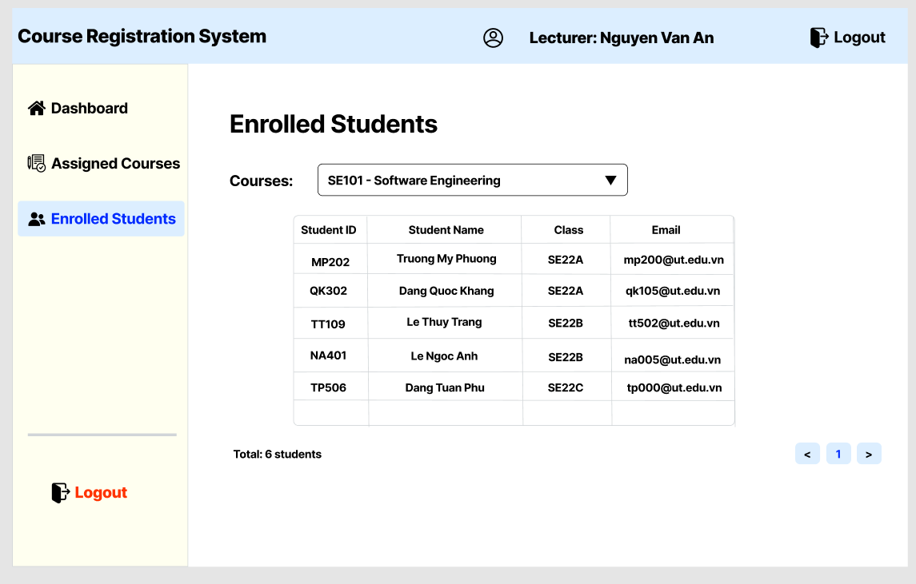
Figure 15: Enrolled Students Interface
Purpose
This interface allows lecturers to view students enrolled in a selected course.
Components
Component | Description
Course Selection | Select course section
Student Table | Displays enrolled students
Student Information | Student details

Admin Dashboard
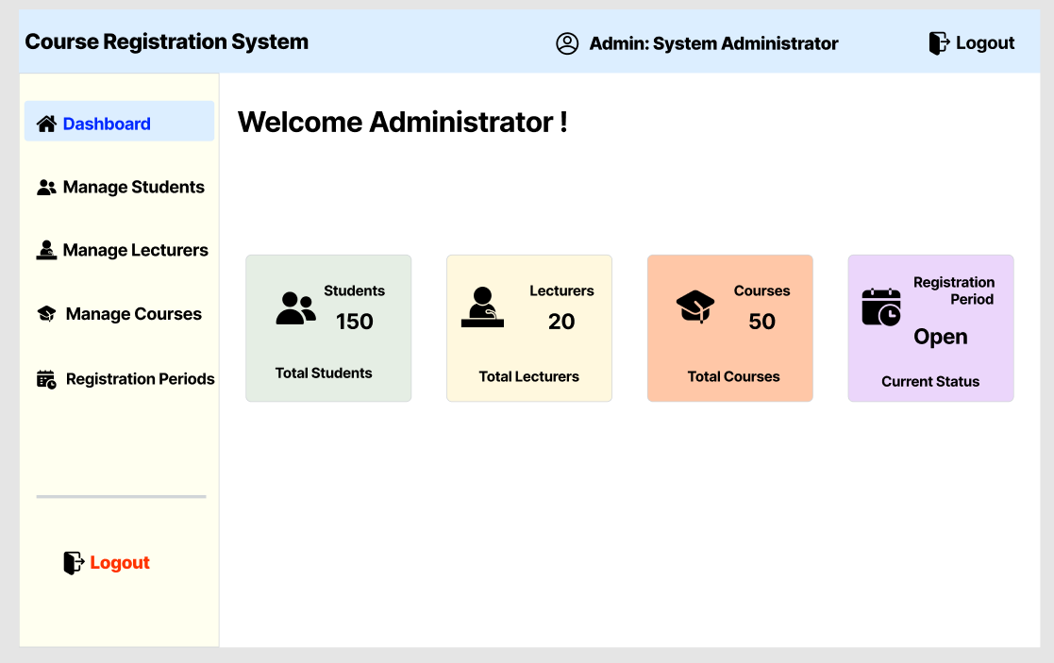
Figure 16: Admin Dashboard
Purpose
The Admin Dashboard provides access to all management functions within the system.
Components
Component | Description
Manage Students Card | Access student management
Manage Lecturers Card | Access lecturer management
Manage Courses Card | Access course management
Registration Periods Card | Access registration management

Manage Students Interface
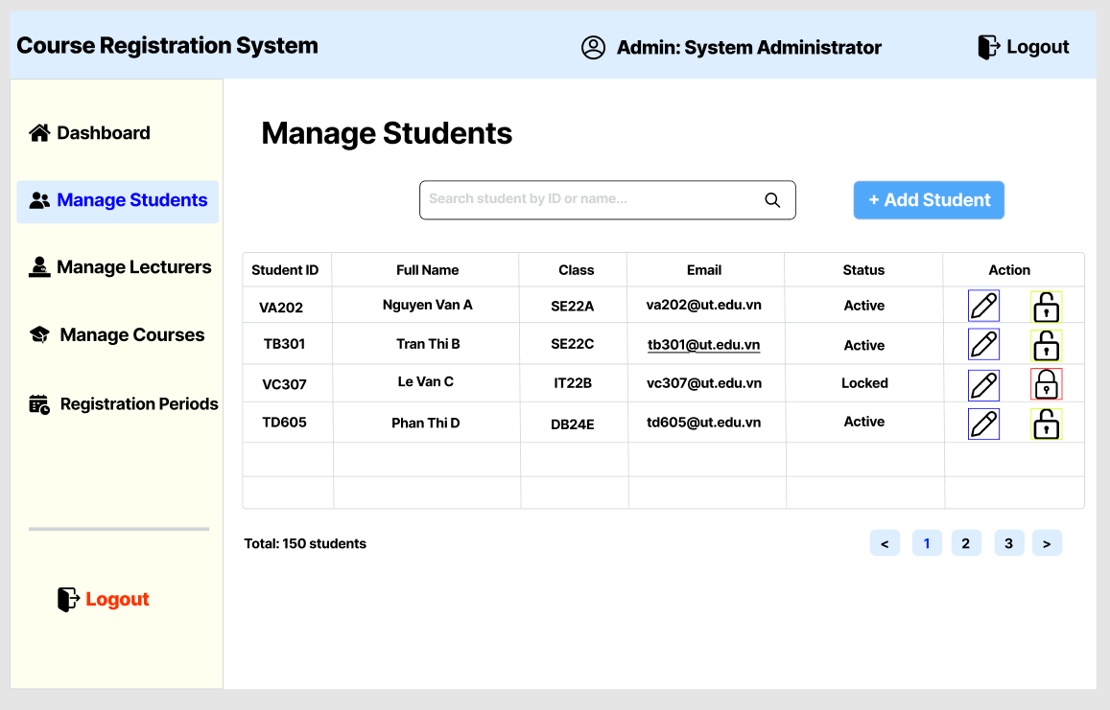
Figure 17: Manage Students Interface
Purpose
This interface allows administrators to manage student accounts.
Components
Component | Description
Search Box | Search students
Add Student Button | Create student account
Edit Button | Update student information
Lock/Unlock Button | Enable or disable account
Student Table | Student records

Manage Lecturers Interface
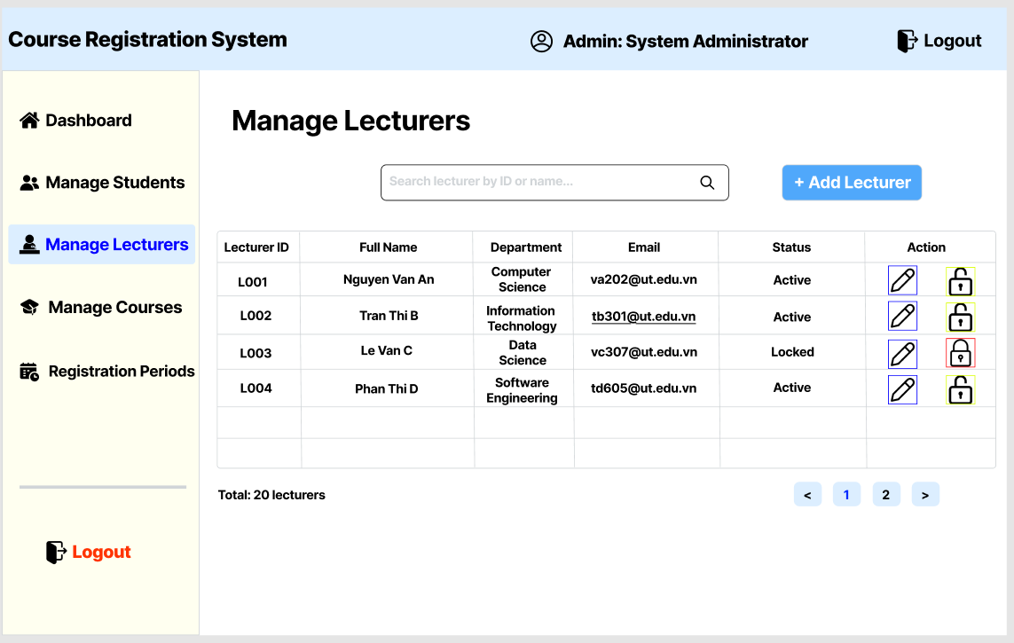
Figure 18: Manage Lecturers Interface
Purpose
This interface allows administrators to manage lecturer accounts.
Components
Component | Description
Search Box | Search lecturers
Add Lecturer Button | Create lecturer account
Edit Button | Update lecturer information
Lock/Unlock Button | Enable or disable account
Lecturer Table | Lecturer records

Manage Courses Interface
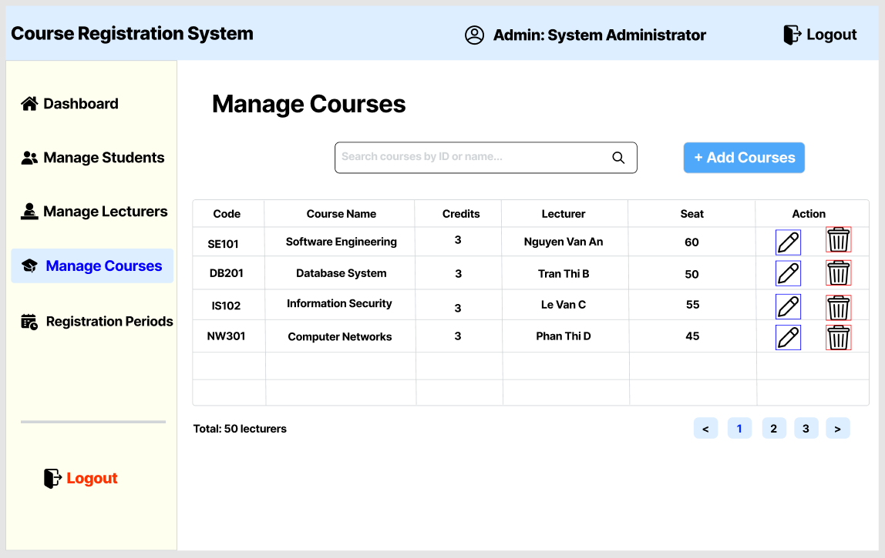
Figure 19: Manage Courses Interface
Purpose
This interface allows administrators to manage courses and course sections.
Components
Component | Description
Search Box | Search courses
Add Course Button | Create new course
Edit Button | Modify course information
Delete Button | Remove course
Course Table | Course records

Registration Periods Interface
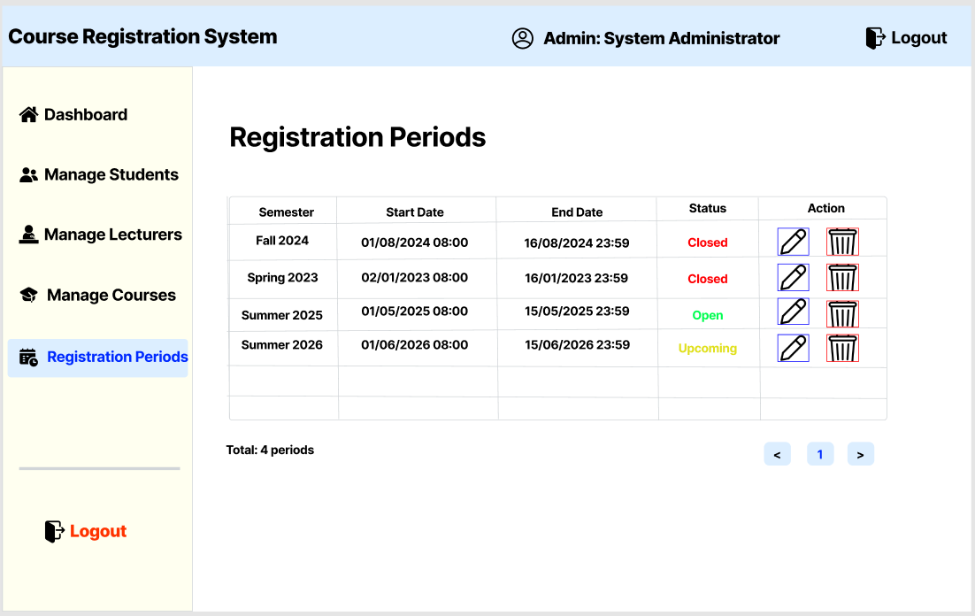
Figure 20: Registration Periods Interface
Purpose
This interface allows administrators to manage registration periods for each semester.
Components
Component | Description
Add Period Button | Create registration period
Edit Button | Update registration period
Semester Field | Semester information
Start Date | Registration start date
End Date | Registration end date
Status | Open or Close registration

